QUESTION 1
a. Describing the crabs dataset
library("MASS")
?crabs

Description
The crabs data frame has 200 rows and 8 columns, describing 5 morphological measurements on 50 crabs each of two colour forms and both sexes, of the species Leptograpsus variegatus collected at Fremantle, W. Australia.

b. loading and displaying the structure
data(crabs) ## To laod the dataset
head(crabs) # to have a preview of the data

str(crabs) # For checking the structure of the dataset

c. a frequency table for species and sex
?table
f_tab_species <- table(crabs$sp)
f_tab_species

f_tab_sex <- table(crabs$sex)
f_tab_sex

bar chart summarizing the groups composition
barplot(f_tab_species, main = "barplot for species",
xlab = "Species",
ylab = "Frequency",
col = 2:3)
barplot(f_tab_sex, main = "barplot for sex",
xlab = "Sex",
ylab = "Frequency",
col = 4:5)

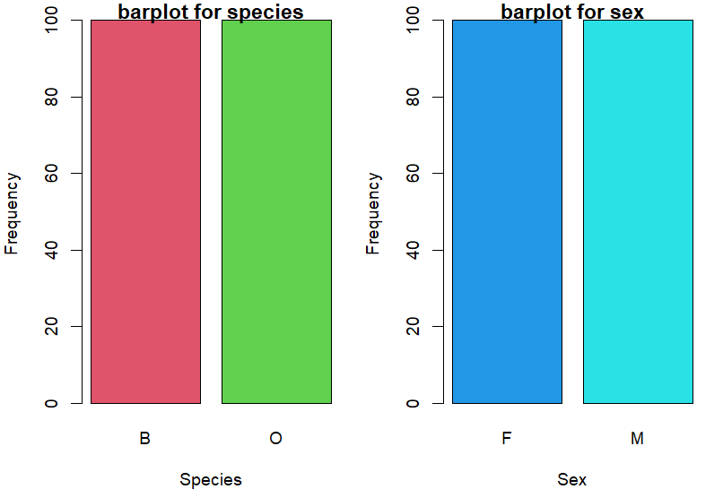
e. Across all four groups the dataset is balanced

QUESTION 2
a.
par(mfrow = c(1, 2), mar = c(4,4,1,1))
boxplot(crabs$BD ~ crabs$sp,
main = "Boxplot of BD by Species",
xlab = "Species",
ylab = "Body depth",
col = 2:3)
boxplot(crabs$BD ~ crabs$sex,
main = "Boxplot of BD by Sex",
xlab = "Sex",
ylab = "Body depth",
col = 4:5)
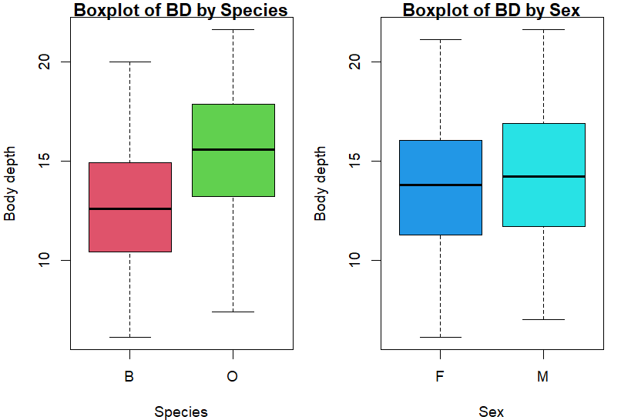

b. from the boxplots there are no outliers .
the species O has the highest median of body depth and species B has the lowest median of body depth.

QUESTION 3
hist(crabs$CL[crabs$sp == "B"],
main = "Histogram of CL (B)",
xlab = "B lenght", col = "lightblue",
ylim = c(0,30))
hist(crabs$CL[crabs$sp == "O"],
main = "Histogram of CL (O)",
xlab = "O lenght", col = "brown",
ylim = c(0,30))

legend("topright", legend = c("B", "O"),
fill = c("lightblue", "brown"))

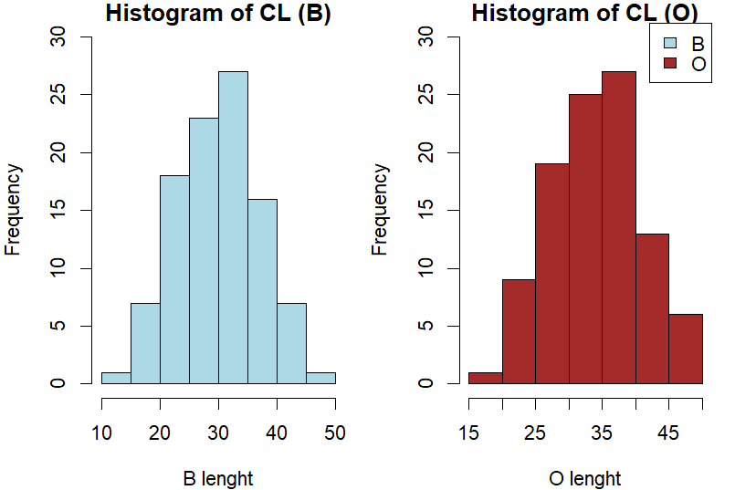
b.
library(psych)

describe(crabs$CL[crabs$sp == "B"])
describe(crabs$CL[crabs$sp == "O"])
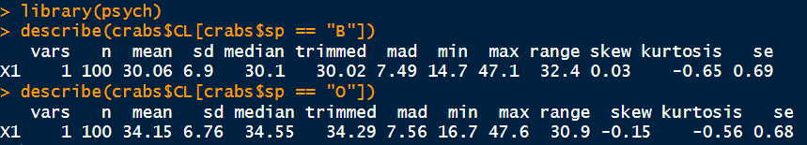

From the describe function and the histograms, the shapes of both are approximately normal
The species has skewness 0.03 and kurtosis -0.65 and the sex has skewness -0.15 and kurtosis -0.56
The mode of the species is 47.1 and sex is 47.6

QUESTION4

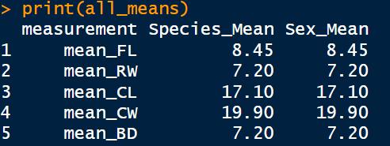
mean_FL_sp <- mean(crabs$FL[crabs$sp])
mean_RW_sp <- mean(crabs$RW[crabs$sp])
mean_CL_sp <- mean(crabs$CL[crabs$sp])
mean_CW_sp <- mean(crabs$CW[crabs$sp])
mean_BD_sp <- mean(crabs$BD[crabs$sp])

mean_FL_sex <- mean(crabs$FL[crabs$sex])
mean_RW_sex <- mean(crabs$RW[crabs$sex])
mean_CL_sex <- mean(crabs$CL[crabs$sex])
mean_CW_sex <- mean(crabs$CW[crabs$sex])
mean_BD_sex <- mean(crabs$BD[crabs$sex])

all_means <- data.frame(
measurement = c("mean_FL", "mean_RW", "mean_CL", "mean_CW","mean_BD"),
Species_Mean = c(mean_FL_sp, mean_RW_sp, mean_CL_sp, mean_CW_sp, mean_BD_sp),
Sex_Mean = c(mean_FL_sex, mean_RW_sex, mean_CL_sex, mean_CW_sex, mean_BD_sex)
)

print(all_means)
b. The grouped Barchat

Species_Mean <- c(mean_FL_sp, mean_RW_sp, mean_CL_sp, mean_CW_sp, mean_BD_sp)
Sex_Mean <- c(mean_FL_sex, mean_RW_sex, mean_CL_sex, mean_CW_sex, mean_BD_sex)

mean_matrix <- rbind(Species_Mean,Sex_Mean)
par(mfrow = c(1, 1))
barplot(mean_matrix,
col = c("skyblue", "orange"),
main = "Stacked Bar Plot",beside = T,
xlab = "means of FL RW CL CW BD",
ylab = "Values",ylim = c(0,25))

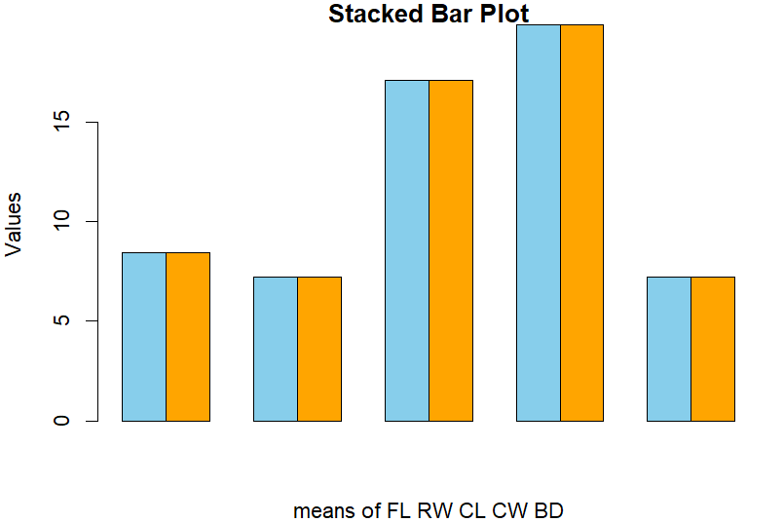

?pairs
pairs(mean_matrix)

